**Litepaper**

|  |  |
| --- | --- |
|  | **PhilanthropyDAO Fund philanthropydao.fund**  **- Work in Progress -**  By JuxtaThePozer.eth |

Mission:

*To provide financial and educational assistance to people who have experienced hard rugs, hacks or exploits in DeFi or the wider crypto space. An open and decentralised charity fund driven by the community, for the community.*

*The PhilanthropyDAO Fund (here on called the “Fund”) is a platform which gives members of the community a means of supporting each other during hard times.*

In Brief:

Donors pay to mint an NFT as a token of their support or choose to donate silently to the Fund. Victims can mint a free NFT “in memoriam” of the project they lost money to and stake it to receive support from the Fund.

But Why?

I believe this type of initiative is lacking within the crypto space. I’ve seen many fellow investors and degens lose a lot of money with little to no recourse available. Although government regulation is coming, it may still be some years before such “investor protections” are implemented. If we can demonstrate to the regulating bodies that we are able to self-regulate using free market techniques, then there will be less people making complaints and ultimately, less regulatory pressure on everyone.

I feel that this Fund could gain traction and support within the crypto ecosystem as a means of supporting the most socially disadvantaged members of our community in a trustless, open and decentralised way. All public money and major decisions are raised on and voted by the PhilanthropyDAO.

This platform could build a type of “social capital” in the crypto-ecosystem, redistributing a small portion of wealth from those with a lot, to those without much. It will help to stop people being turned off from crypto and ultimately, help to keep liquidity within the system, which benefits everyone in the ecosystem.

Crypto and DeFi crosses international borders and offers financial tools to anyone with an internet connection and a willingness to learn. I believe we are at the precipice of a new era of prosperity which has the ability to offer economic opportunities to those who previously never had access to it. Socially and economically disadvantaged groups arguably have the greatest opportunity however, they are also at the greatest risk as many are learning the hard way.

It is my vision that this philanthropic/charity fund can eventually grow to help new DeFi projects access funding for audits and initiatives which will improve their own safety and security, offer educational content on how to spot scams and onboard people from disadvantaged communities into yield generating opportunities.

Tokenomics

A list is maintained by the project team (prototype at <https://patrik.finance> DeFi Graveyard) and listed on the project site, with new rugs/hacks added as they occur and become known to the team through social channels, community members and places like rekt.news

It may be necessary to categorise dead projects with a “degen category”, in order to quantify the amount of assumed risk that people took on when they decided to invest in any given project. This may affect the total percentage allocation made available to them by the Fund.

For example, a) if an assumedly safe, well-audited and battle-tested project such as Aave were to suffer an exploit that resulted in the loss of $20M, as opposed to b) a high risk yield farm that hadn’t yet completed one audit, was around for less than a month and suffered losses of $50M. Despite *project a* suffering less total loss, it may be seen as unfair if *project b* were entitled to a higher percentage of compensation from the Fund. Investors take on a certain level of assumed risk and I believe this will need to be priced into the compensation weighting. This topic may be best developed and decided upon by the Fund DAO by means of finding the “degen score” against a “risk matrix.”

There is no native token to the project. Funds are aggregated in the native token of the platform the rug/exploit occurred on (MATIC) or a stable-coin (DAI, USDC, USDT, MAI etc), thereby increasing security and decreasing layers of obfuscation and potential volatility of secondary tokenomics.

The Fund has two types of people: Donors or Victims

Donors

* Donors visit a front-end site and can choose to donate in one of the two following ways:
  1. One-off, non-refundable stable-coin donation to one or more projects of their choice (percentages must add to 100%). The entire amount goes to the Project Fund(s) of their choice.
  2. Vaulted donation to a project(s) of their choice (percentages must add to 100%)
     + They can stake amMATIC, amDAI, amUSDC, amUSDT, amWETH or amWBTC and this initiates a personal “Vaulted Trust” for them in Aave, using a fork of [Polycat Aave strategy](https://github.com/polycatfi/polycat-contracts/blob/master/Vault2/StrategyAave.sol) that earns yield with APY displayed on the Fund site). The Polycat main dev Kevin Ma has offered to assist.
     + The donor chooses a percentage of yield to receive, the remainder is sent to the Vaulted Fund. Recommended default is 50-50.
     + They can un-stake their funds at any time, therefore initiating a withdrawal and ceasing their donation to the Fund.
     + Other future strategies can be debated and voted on by the DAO.
* They can either choose a “silent donation” (no NFT) or to mint an NFT during the process (the encouraged default option). This NFT contains metadata such as their “tier” (more on this below).  
  The NFT becomes their “receipt” but more importantly, acts as a symbol of their charity and good will.
* Donors can sell their NFT’s at any time but a percentage of the sale is captured by the Fund at the time of the sale (50%?)
* Fund partners (eg. Dogematic/STRG, RugDoc, Polycat(?) and other projects who are positioned for the “public good”) will be sought out and invited to donate or contribute in some way.
  + Project partners can use a “seal” image on their site which links to their NFT as a means of displaying their charity and potentially increasing their reputation within the community.
  + Each donation amount will fall into a tiered system, ie. Bronze, Silver, Gold, Platinum. This donation tier will be displayed on their NFT.
    - Bronze: 0-10 USDC/USDT/DAI/MAI
    - Silver: 10-100 USDC/USDT/DAI/MAI
    - Gold: 100-1000 USDC/USDT/DAI/MAI
    - Platinum: >1000 USDC/USDT/DAI/MAI
  + A suggested NFT structure could incorporate rarity such as an available amount, reset each fundraising round which could last a month or a new round launched as a new rug/exploit/hack is discovered and fund-raising efforts increase.
    - Bronze tier: 1000/round
    - Silver tier: 500/round
    - Gold: 100/round
    - Platinum: 10/round
* Victims
  + Victims must first sign a transaction to verify they have been affected. This causes a contract to check their wallet address against an updated list of masterchefs/vaultchefs and determines eligibility of a “claim” and what their percentage stake of the vault/pool/farm was at the time just prior to funds being drained (snapshot strategy, updated as a new rug/exploit/hack is investigated).
    - Each “claim” contains data such as:
      * Name of the Rugged Project
      * The TVL of the project broken down into token(s) and USD value(s) at a snapshot block height
      * The victims percentage stake of the pool(s) at the block height including pending rewards unclaimed
      * Their Total Lost Value (TLV), broken down into token, pool/vault and platform
  + They can then mint a free Victim NFT for whichever project they lost funds on. This is therefore an opt-in service. No one will receive funds or have anything sent to them without their consent.
  + The victim then stakes their NFT on the philanthropic project site and they will start their own “Claim Fund”.
    - A pre-determined percentage of donations which were used to pay for Donor NFT’s.
    - Regular yield from staked amVaults which can be claimed at their convenience.
  + Open for consideration: 2x NFT’s
    - One for staking, which is used to receive donations
    - One as a receipt, which can be displayed on Opensea etc. “in memoriam” of the project that rugged them
  + “Fair distribution” They will only ever receive a percentage of the total rewards proportional to initial determination, in perpetuity or until their total value lost is recovered.
  + In the unlikely event of more donations than recipients, an “Overflow Fund” can be established, with future use-cases TBD and decided on by the Fund DAO.
  + The proportional amount they receive could change in the future depending on community/DAO vote, in order to weigh in favour more towards the little guy. This may align with greater community expectation that only disadvantaged people should be eligible for social support or more support than those who already potentially started with more.
    - This is a tricky social dilemma and is outside the scope of this document but worth noting nonetheless.

Project Funds

Vaulted Funds

amMATIC

amDAI

amUSDC

amUSDT

amWETH

amWBTC

**Donor**

Rug #1

Rug #2

Rug #3

Rug #4

Rug #5

Rug #6

< or >

% return ratio

% of yield

Overflow Fund

All Funds are aggregated into  
amUSDC before distribution.

Yield Fund #1

Yield Fund #2

Yield Fund #3

Yield Fund #4

Yield Fund #5

Yield Fund #6

All one-off donations are aggregated into  
amUSDC Yield Funds before distribution.

**Victim**

**Rugged Projects**

Victim Claims

Database containing key details such as:

Rug Name

TVL at snapshot

Pools & Tokens

Staking locations

Rug #5 Claim

Rug #6 Claim

Rug #3 Claim

Rug #4 Claim

Rug #1 Claim

Rug #2 Claim

NFT

[claimVerify] Wallet checked against database of all known rugs.

NFT staking

NFT

Their Total Lost Value and % of TVL determined.

Overflow Fund usage can be voted on by the DAO for spending on “philanthropic projects” such as Education, Audits etc. aimed at “disadvantaged communities”.

Overview

NFT’s

Each project has a different NFT. The style intent is that it is clean, tasteful but a little snarky and tongue-in-cheek. Images are in the style of a collectible card, such as those representing a staking position on Uniswap V3, Mai Finance etc. Minimal animation. Perhaps a little flickering candle “in memoriam”.

* Chain logo the project was on (Polygon first but potentially others too down the track. BSC?)
* Logo of the project that rugged on top of a hard, shitty looking, uncomfortable rug in the centre
* TVL lost/stolen
* Which tokens within that project were stolen
* Main token of the farm or token their rewards were paid out in
* Contract addresses of affected contracts (along the borders)
* Dynamic elements
  + Contract of the rug
  + Their wallet address?
  + The “tier” their donation falls into as a coloured coin: Bronze, Silver, Gold, Platinum  
    Or background colour/design element
* Donor or Victim cards either have a different colour border or are titled Donor or Victim.
* Mock up, Gold and Bronze tier NFT’s:  
    
  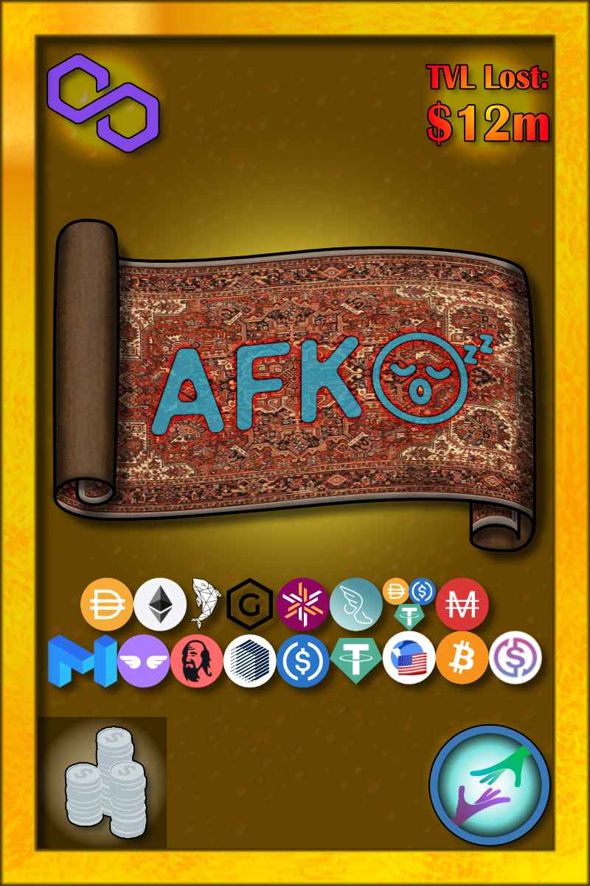 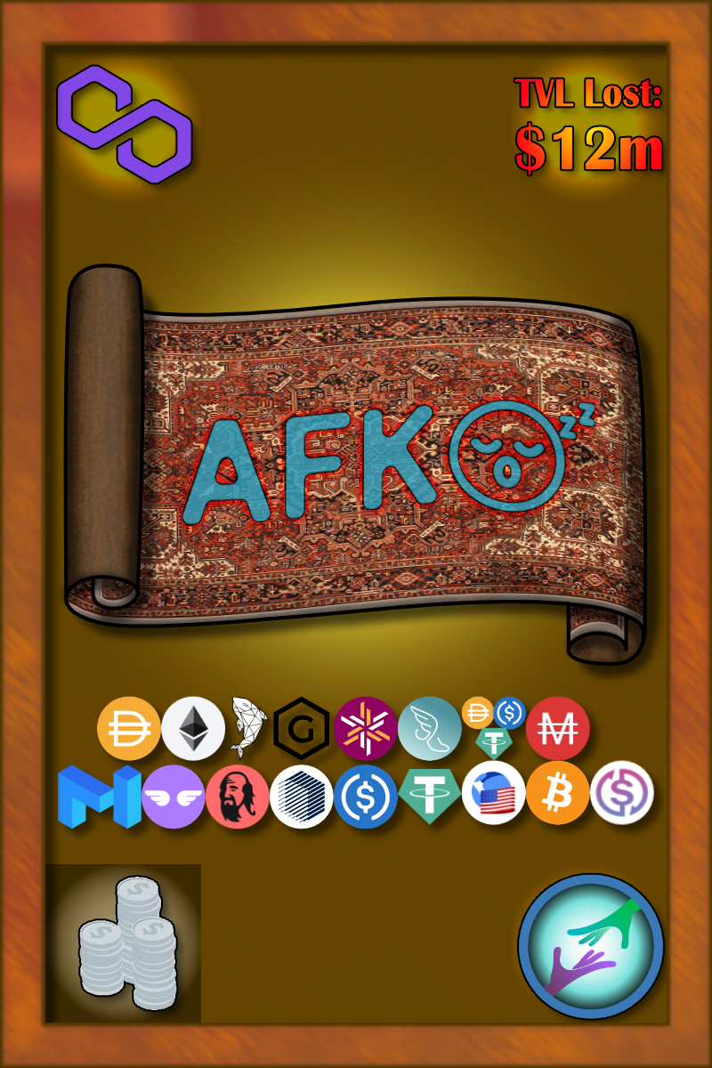

Fund distribution - [Economic Feasibility study here](https://docs.google.com/spreadsheets/d/1e0YScvy55a7EZ6tvjx38duiNG4WQdfi-fLuH_BuS0kg/edit?usp=sharing)

* 5-10% of donations go to Philanthropic Project for
  + Marketing and development (minimal, would prefer word of mouth)
  + Audits (expensive but vital for public perception)
  + Economic incentive for team to put more time into the project, pursue further partnerships, stay abreast of community sentiment/management and develop project further (contentious)
* 45-47.5% of donations go to the Victims, distributed evenly as donations come in.
* 45-47.5% of donations are staked in the safest location known to exist in DeFi, with yields either dripped into Victims wallets or made available for harvesting.

DAO

Mentioned previously, this will be vital to establish early on since the primary purpose of the platform is for it to be run by the community, for the community.

A token-based DAO mechanism will likely not work, since there will be no native token nor do I believe there should be, since this does not align with the goals of the Fund.

Posting links/info here for future research:  
<https://xdai.colony.io/colony/truthactionproject/extensions/VotingReputation>

<https://debank.com/vote>

Team/tasks required

* Smart contract writers - Kevin, Zatch, Duncan
* NFT artist - Juxta
* Community management - Juxta, Patrik, Arfonzo, UnholyWarcry
* Front-end website - Patrik, Duncan
* Marketing and Partnerships - Juxta, UnholyWarcry

Transparency and audits

* Initial Rugdoc or similar audit
* Detailed audit - Certik, Obelisk, Paladin etc
* Community feedback via webform, telegram, discord etc
* Verifiable on-chain activity
* Potential DAO formation, structure TBD
* All decisions and notifications posted to website and social channels

Feasibility study (SWOT analysis, internal/external)

* Strengths (internal factors)
  + Unique concept. I don’t know of any such coordinated “social support” fund which can provide an opt-in mechanism to help affected people.
  + Personal experience. Some team members are experienced DeFi users and have themselves been rugged, so we’ve done it hard and know the pain.
  + Public perception. As forward-facing community mods, this team is largely comprised of people already known within the community and have garnered some reputation.
* Weaknesses (internal factors)
  + Time-limits. Currently identified team members may have other priorities with work, family.
  + Lack of data. Currently lacking information which states beyond doubt that this sort of project would be widely accepted or used within the crypto community.
  + Economic feasibility. This is all predicated on the philanthropic willingness of Donors.
* Opportunities leveraging Strengths (external factors)
  + Existing partnerships. Rugdoc has already decided to partner with Polycat so there is an existing in-road and open line of communication with another widely known, grass-roots, community-driven project.
  + Dogematic may be interested in becoming donors. They already have an initiative (info at
  + Other projects who want to be seen as community friendly, may wish to involve themselves and offer an air of security/comradery to the members of their platforms.
* Threats posed by Weaknesses (external factors)
  + Crypto winter. During times of down-turn or low rug behaviour, the economic activity generated by the Fund participants will decrease and the project goes to sleep.
  + Philanthropic assumptions, based on people's predicted willingness to donate to the Fund may be overstated and the project may not actually receive enough donations to make it worth the time of the team to continue the project.
  + Encouraging rugging. If a project or participants know that this “charity” exists they may feel more comfortable either undertaking deceptive, ruggy behaviour or poor investment decisions based on a lack of research.
  + Victims who do not mint/claim their “compensation” from the Fund, perhaps due to ignorance of the project or something. What to do with their funds? Perhaps a 90 day claim period can be implied, wherein any percentage claim they may have had will expire and be distributed evenly among all other victims but reimburse no more than what they originally lost. Good marketing/visibility of the project should prevent anyone from not claiming. Any leftover funds can be locked into an “overflow” Fund, the use of which can be decided upon by the community/DAO.

Closing Thoughts

Full disclosure. If I think this project is viable, I am willing to put up a chunk of my own funds. Up to or around $20-40k, depending on a balanced assessment of the risks vs reward.

If I’m able to recoup that, well that’s great. But my primary motivation is to just do something meaningful for people and which could have a positive impact on the strength of our community and the crypto ecosystem as a whole. I’m even prepared to dox myself if I thought it would lend the project any credibility, though I’m not sure that would make much difference either way.

I would happily spend my days rallying the troops to fight the good fight. It strikes deep at the heart of my values and if I thought I could make a humble living off of doing something worthwhile, then the real reward would be seeing our nascent ecosystem flourish into an engine of wealth generation for people who never previously had access to these tools.

I’ll quit my job tomorrow if I think I can survive while doing something like this. I've been looking for a good excuse for a while now. I’m starting to look at funding opportunities and investments from people who might be interested in something that provides “social capital” improvements to the ecosystem. I know it’s not going to be a money printer, the benefits of something like this are far less tangible. However if we can help to keep people turned off from crypto because they keep getting rekt, well then this has flow-on benefits for everyone.